Basics of Image Processing

# What is Image Processing ?

Image processing is a method to perform some operations on an image, in order to get an enhanced image or to extract some useful information from it.

It is a type of signal processing in which input is an image and output may be image or characteristics/features associated with that image. Nowadays, image processing is among rapidly growing technologies.

Image processing basically includes the following three steps:

* Importing the image via image acquisition tools;
* Analyzing and manipulating the image;
* 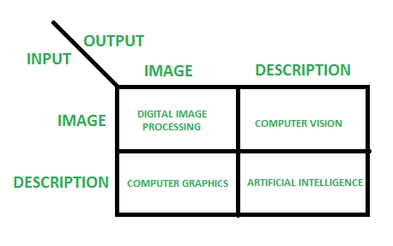Output in which result can be altered image or report that is based on image analysis.

**Reference :**

* <https://sisu.ut.ee/imageprocessing/book/1>
* https://www.google.com/amp/s/www.geeksforgeeks.org/digital-image-processing-basics/amp/

**Wh**